--QUESTIONS

-- 1. What is the total amount each customer spent at the restaurant?

SELECT

s.customer_id,

SUM(m.price) AS total_spent

FROM sales s

JOIN menu m

ON s.product_id = m.product_id

GROUP BY s.customer_id

ORDER BY s.customer_id;

**RESULT:**

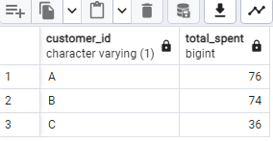

-- 2. How many days has each customer visited the restaurant?

SELECT

customer_id,

COUNT(Distinct order_date) AS visit_days

FROM sales

GROUP BY customer_id;

**RESULT:**

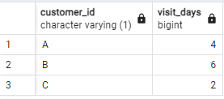

-- 3. What was the first item from the menu purchased by each customer?

WITH orders_rank As

(

SELECT customer_id,

order_date,

product_id,

DENSE_RANK()OVER(PARTITION BY customer_id ORDER BY order_date ASC ) AS orders_rank

FROM sales

)

SELECT

o.customer_id,

m.product_name

FROM orders_rank o JOIN menu m

ON o.product_id=m.product_id

WHERE o.orders_rank=1

ORDER BY o.customer_id;

**RESULT:**

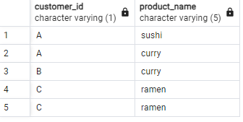

--CAN USE DENSE_RANK/ROW_NUMBER SINCE THERE IS NO TIMESTAMP IS GIVEN

-- 4. What is the most purchased item on the menu and how many times was it purchased by all customers?

SELECT m.product_name,

COUNT(m.product_name) AS most_count

FROM sales s JOIN menu m

ON s.product_id=m.product_id

GROUP BY m.product_name

ORDER BY most_count DESC

LIMIT 1;

**RESULT:**

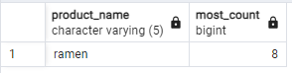

-- 5. Which item was the most popular for each customer?

WITH Fev_item AS(

SELECT

s.customer_id,

m.product_name,

COUNT(m.product_id) AS order_count,

DENSE_RANK() OVER(PARTITION BY s.customer_id ORDER BY COUNT(s.customer_id)DESC) AS rnk

FROM menu AS m

JOIN sales As s

ON m.product_id=s.product_id

GROUP BY 1,2

)

SELECT customer_id,product_name,order_count

FROM fev_item

WHERE rnk=1;

**RESULT:**

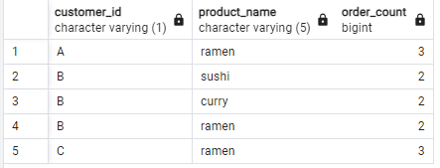

--Cust A likes ramen most,

B likes all the items,

C likes ramen most.

-- 6. Which item was purchased first by the customer after they became a member?

WITH member_cte AS

(

SELECT

s.customer_id,mb.join_date,s.order_date,s.product_id,

DENSE_RANK() OVER(PARTITION BY s.customer_id

ORDER BY s.order_date) AS rnk

FROM sales s

JOIN members mb

ON s.customer_id=mb.customer_id

WHERE s.order_date>=mb.join_date

)

SELECT c.customer_id,c.order_date,m.product_name

FROM member_cte c

JOIN menu m

ON c.product_id=m.product_id

WHERE rnk=1

ORDER BY c.customer_id;

**RESULT:**

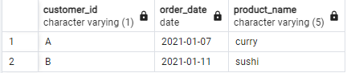

-- 7. Which item was purchased just before the customer became a member?

WITH before_member_cte AS

(

SELECT

s.customer_id,mb.join_date,s.order_date,s.product_id,

DENSE_RANK() OVER(PARTITION BY s.customer_id

ORDER BY s.order_date DESC) AS rnk

FROM sales s

JOIN members mb

ON s.customer_id=mb.customer_id

WHERE s.order_date<mb.join_date

)

SELECT bc.customer_id,bc.order_date,m.product_name

FROM before_member_cte bc

JOIN menu m

ON bc.product_id=m.product_id

WHERE rnk=1

ORDER BY bc.customer_id;

**RESULT:**

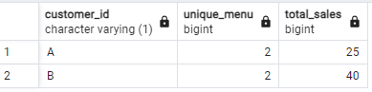

-- 8. What is the total items and amount spent for each member before they became a member?

SELECT s.customer_id,

COUNT(DISTINCT s.product_id) AS unique_menu,

SUM(m.price) AS total_sales

FROM sales AS s

JOIN members AS mb

ON s.customer_id = mb.customer_id

JOIN menu AS m

ON s.product_id = m.product_id

WHERE s.order_date < mb.join_date

GROUP BY s.customer_id;

**RESULT:**

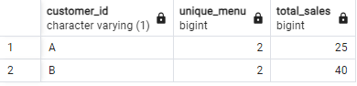

--Before becoming member

A ordered 2 items and spent total 25

And B ordered 2 items and spent 40.

-- 9. If each $1 spent equates to 10 points and sushi has a 2x points multiplier -

-- how many points would each customer have?

WITH cte

AS

(

SELECT

product_id,product_name,price,

CASE

WHEN product_name='sushi' THEN price*20

ELSE price*10

END AS points

FROM menu

)

SELECT

s.customer_id,

SUM(c.points) AS totalPoints

FROM cte c

JOIN sales s

ON c.product_id=s.product_id

GROUP BY s.customer_id

ORDER BY s.customer_id;

**RESULT:**

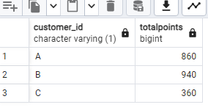

-- 10. In the first week after a customer joins the program (including their join date)

-- they earn 2x points on all items, not just sushi - how many points do customer A and B have at the end of January?

WITH date_cte

AS

(

SELECT

customer_id,

join_date,

join_date + INTERVAL '6 DAYS' AS first_week,

(DATE_TRUNC('MONTH','2021-01-31'::DATE)+ INTERVAL '1 MONTH'-INTERVAL '1 DAY') AS last_day

FROM members

)

SELECT s.customer_id,

SUM(

CASE WHEN m.product_name='sushi' THEN 2*10*m.price

WHEN s.order_date BETWEEN dc.join_date AND dc.first_week THEN 2*10*m.price

ELSE 10*m.price

END) AS points

FROM sales s

JOIN date_cte dc

ON s.customer_id=dc.customer_id

JOIN menu m

ON s.product_id=m.product_id

WHERE

dc.join_date<=s.order_date

AND s.order_date<=dc.last_day

GROUP BY s.customer_id

ORDER BY s.customer_id;

**RESULT:**

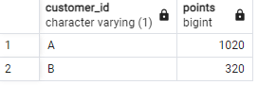

--BOnus questions

--JOIN ALL THINGS

-- Recreate the table with: customer_id, order_date, product_name, price, member (Y/N)

SELECT

s.customer_id,

s.order_date,

m.product_name,

m.price,

CASE

WHEN mb.join_date>s.order_date THEN 'N'

WHEN mb.join_date<=s.order_date THEN 'Y'

ELSE 'N'

END

AS member

FROM sales s

LEFT JOIN menu m

ON s.product_id=m.product_id

LEFT JOIN members mb

ON s.customer_id=mb.customer_id;

**RESULT:**

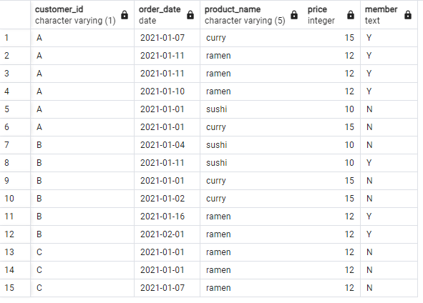

--Rank All The Things

WITH cust_cte AS

(

SELECT

s.customer_id,

s.order_date,

m.product_name,

m.price,

CASE

WHEN mb.join_date>s.order_date THEN 'N'

WHEN mb.join_date<=s.order_date THEN 'Y'

ELSE 'N'

END

AS member

FROM sales s

LEFT JOIN menu m

ON s.product_id=m.product_id

LEFT JOIN members mb

ON s.customer_id=mb.customer_id

)

SELECT customer_id,order_date,product_name,price,member,

CASE

WHEN member='N' THEN NULL

ELSE RANK() OVER(PARTITION BY customer_id,member ORDER BY order_date)

END AS ranking

FROM cust_cte;

**RESULT:**

